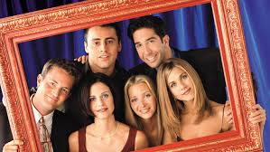

GENERATION FRIENDS:
An Inside Look at the Show that
Defined a Television Era

Online on Sunday, July 14, 4:00 PM

Journalist Saul Austerlitz’s latest book, Generation Friends, reveals the inner workings of the legendary TV comedy series Friends. He has frequently written on film and television, and his articles have been published in the New York Times, New York Times Magazine, Esquire, Rolling Stone, Los Angeles Times, and The New Republic. He is also an adjunct professor of writing and comedy history at NYU. Admission to this special online author event is free.

To purchase the book: http://www.rakestrawbooks.com/book/9781524743352
For the ZOOM link for this July 14th author event, go to:
Bnaishalom.org or underonetent.org. You may also email rivagambert@gmail.com



