Yom HaShoa
Ve Ha’Gevurah
Wednesday, April 27, 2022 – 7:00 PM

In-person at Temple Isaiah and On-line
An Evening
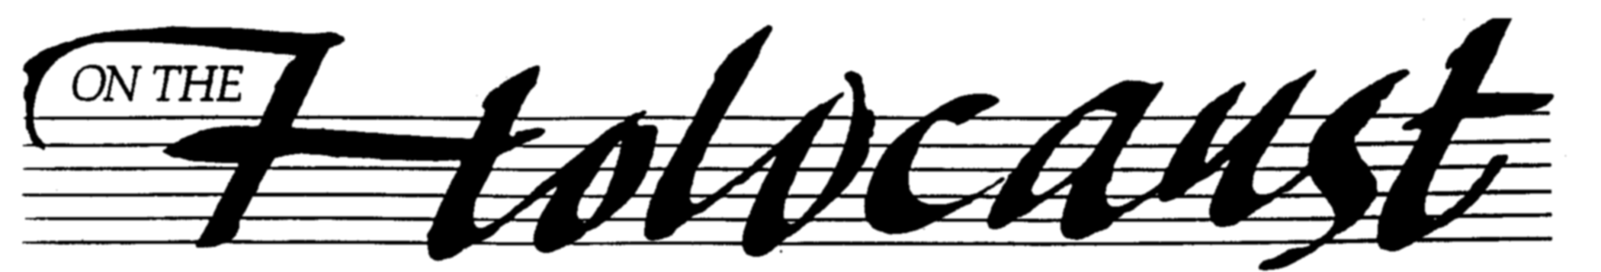

Join the community in remembrance and solidarity.
Guest Speaker: Dr. Michael Berenbaum will speak to us from Poland. He served as Deputy Director of the President's Commission on the Holocaust, Project Director of the United States Holocaust Memorial Museum and president of the Survivors of the Shoah Visual History Foundation created by Steven Spielberg. Admission is free and open to the public.

To watch the commemoration on-line:
https://www.youtube.com/TIJewishNeighborhood

From 9:00 PM to midnight, the annual “reading of names” of those who perished in the Holocaust will be presented on-line. For the link to the reading and Covid social-distancing protocols, please go to: underonetent/yomhashoa.

Convened by the Contra Costa JCC. Sponsored by Beth Chaim Congregation, Congregation Beth Emek, Congregation B’nai Shalom, Congregation B’nai Tikvah and Temple Isaiah.

Co-sponsors: Contra Costa Jewish Day School, Contra Costa Midrasha, Diablo Valley Hadassah, East Bay International Jewish Film Festival, East Bay Holocaust Education Center, Israeli American Council, JEICOR, New Lehrhaus and The Reutlinger Community

